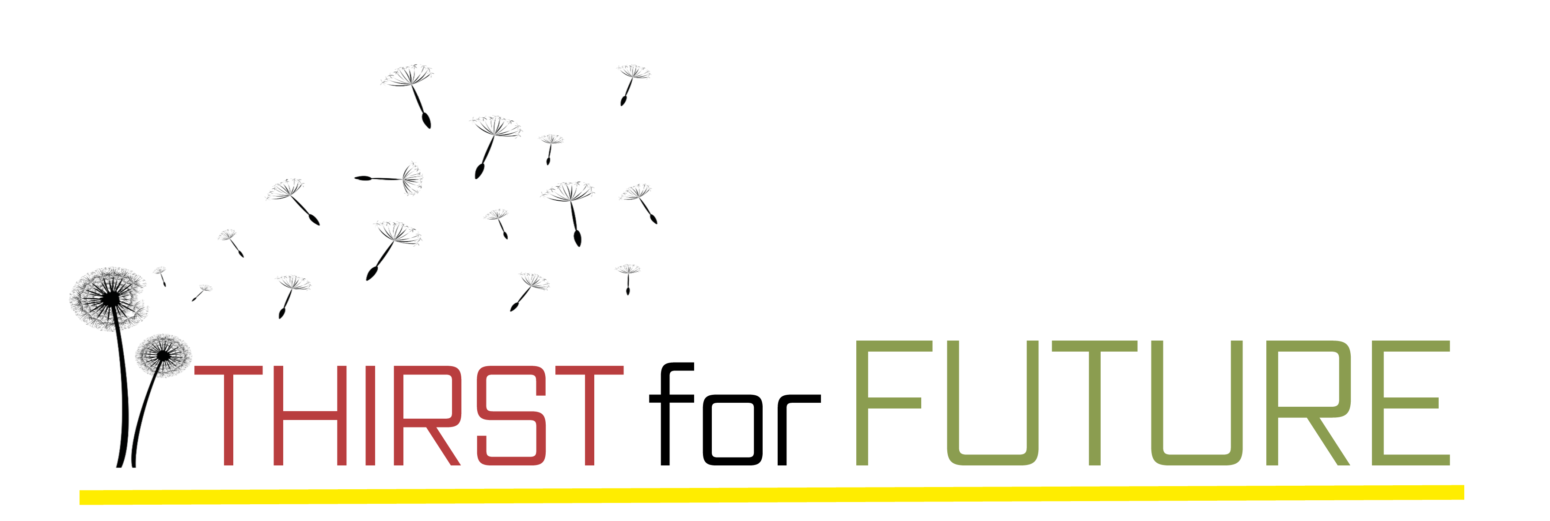

European Village Renewal Award 2024

of the

European Association for Rural Development and Village Renewal

under the motto

Thirst for future

Contents:

- Intention
- Motto
- Criteria for judging entries
- Prizes
- Conditions for entry
- Documents to submit
- Schedule
- Contact information

Intention

The competition surrounding the 18th European Village Renewal Award is guided by the intention to highlight and award extraordinary and exemplary processes of development and renewal within the rural community. The respective initial conditions, the economic and socio-cultural context as well as country-specific standards and characteristics are taken into account.

The primary criterion is that the projects and processes contribute to strengthening the future viability of rural areas and improving the quality of life in accordance with the "Model of the European Association for Rural Development and Village Renewal for the Sustainable Development of European Villages and Rural Communities".

The competition therefore emphasizes rural communities

- who face the current challenges of their living space with sustainable, innovative and contemporary projects and have initiated holistic development processes;
- who seek to involve all sections of the population in local events and, in this way, gain different perspectives, broader horizons and more diverse ideas;
- who are aware of the value and necessity of cooperation and subsequently rely on networks as well as intermunicipal and regional associations.

Motto

The motto "Thirst for future" takes into account that the major turning points of recent years and the enormous challenges that people are confronted with have left deep scars. In many places, pessimism, social opposition and paralyzing fears are the consequences. The motto "Thirst for future" therefore wants to be a signal to recognize not only the dangers, but to also recognize and use the opportunities that are inherent to a forward-looking and passionate shaping of our own living space.

Criteria for evaluation

The central question of the evaluation is how the participating community responded to

• Strengths and weaknesses and
• internal and external threats and opportunities

that arose during the renewal process.The quality and content of the projects are just as important as the methods used.

Specifically:

A. Methods and Strategies

1. Personal initiative and citizen participation
2. Interaction between citizens, politics and administration
3. Inter-municipal and inter-regional cooperation, public-private partnerships and networks
4. Inclusion of expertise in conception, consulting, planning and process support
5. Congruence and holistic concept

B. Topics and goals

- Ecology: Responsible use of resources in the sense of circular economy, use of renewable materials, generation of renewable energies; environmental and nature protection and strengthening of biodiversity; Climate protection and adaptation to climate change
- Economy: Strengthening of location-compatible employment opportunities as well as environmentally friendly and climate-resilient agriculture and forestry; valorization of the cultural landscape and promotion of regional value chains
- Society: Creation of modern social facilities, promotion of education and training, inclusion as well as health and medical care, strengthening of the public welfare and the participation of all generations, genders, nationalities and minorities in economic, social and cultural life
- Ensuring sustainable and long-term affordable services of general interest in the areas of: local supply, mobility and communication infrastructure; Making use of the opportunities of digitization
- Preservation, conversion and sustainable revitalization of the building stock as well as new construction with special attention to quality, resource conservation and local building culture; Preservation, contemporary development and design of cultural landscapes and of empty, agricultural and public spaces
- Promotion of artistic commitment, sporting activities and high-quality leisure activities; Preservation, maintenance and further development of cultural heritage

Prizes

For the 2024 competition, the following prizes will be awarded:

- The European Village Renewal Award 2024 – is awarded to the winner
- European Village Renewal Awards in Gold – they are awarded to those participants who address the current challenges of their living space with sustainable, innovative, and contemporary projects and who have initiated holistic development processes of outstanding quality.
- European Village Renewal Awards in Silver – these are awarded for special achievements in several fields of village development and will be bestowed upon those participants whose assessment is largely positive,
- European Village Renewal Awards in Bronze – these are awarded for special achievements in individual fields of village development

- Optional: special awards for outstanding lighthouse projects in individual subject areas or in methodical terms.

All other participants will receive “laudatory acclaim”.

Awards will be non-monetary, but will consist of symbolic prizes such as trophies,
commemorative plaques and diplomas.

Conditions for entry

Participation eligibility

Per country or region, only

- one village or
- one rural community (consisting of one or more rurally characterized settlements/villages/districts/cadastral communities) or
- one intercommunal association (consisting of two or more rurally characterized municipalities) with no more than 20.000 inhabitants

can be nominated as a participant in the competition.

Nomination eligibility

Nominations are to be made by the politicians or administrators responsible in each country or region for village renewal and rural development, or alternatively by non-governmental organizations (NGOs) or other agencies in the absence of official nominations by the authorities.
Entrance fee

- 600 Euro for villages/municipalities/intercommunal associations from countries, provinces or regions that are members of the European Association for Rural Development and Village Renewal.
- 1.900 Euro for all others.

The entrance fee will be invoiced after the entry and is to be transferred to the bank account of the European Association for Rural Development and Village Renewal by March 15, 2024:

Bank: Raiffeisenlandesbank Niederösterreich-Wien AG
IBAN: AT62 3200 0000 0065 8955
BIC/SWIFT: RLNWATWW

Documents to submit:

- Entry form: fully completed and signed (the signature can be done manually when submitted additionally in printed form, or digitally)

- Form(s) “Lead project”: a minimum of one, maximum of five completed forms

- Photos: at least 15 photos (of persons, landscape, buildings, projects etc.), which can also be used for the press work and publications by the European Association for Rural Development and Village Renewal. Please also include a legend (the images should be print-ready and have a resolution of 300 dpi or be suitable for it). We assume that you or your community hold the copyright for the submitted photos. If this is not the case, please provide the copyright information.

- Digital poster: Plans, graphics, photographs, explanatory text, "before and after" representations etc., should preferably be summarized in a poster. This should facilitate a clear understanding of the measures and also be suitable to be exhibited.
- Ideally, the digital posters should be available in small and printable resolution. Please forward this small version to us. For the exhibition during the award celebration, you can bring a larger print version to decorate your booth.

- Plans: Area usage plan, a topographic maps, aerial images or other representations and explanations that provide information on the current area usage and planned settlement development

- Optional documents: Additional relevant information and presentation material may be included.

Submission

All documents must be sent by 1st of March:

- electronically via WeTransfer or similar services to info@landentwicklung.org

- or by mail (electronic data on a USB drive) to:

Europäische ARGE Landentwicklung und Dorferneuerung
Bahnhofsring 48/ Stiege 1/5b
3451 Pixendorf
Österreich/Austria
A combination of electronic and postal submission of documents is also possible.

Please submit the forms in electronic format in any case, even if you send the signed version of the participation form by mail in printed form.

Schedule

until 15.12.2023: Nomination of participant (Late entries are possible until 01.03.2024)

01.03.2024: Deadline for entries and document submissions

March/April 2024: 1. Assessment meeting of the jury

May/June 2024: On-site visitations of jury-members in the participating communities

June/July 2024: 2. Assessment meeting of the jury, decision
Announcement of results

September 2024: Award ceremony in Stadtschlaining (winner of the competition 2022), Burgenland, Austria as part of a multi-day celebration of encounters – with a Europe-wide exchange of experiences, presentation of the participants of the European Village Renewal Award 2024, informative and attractive program, and last but not least, shared celebrations – to which you are welcome to attend with a larger delegation from your community.

Contact information

Theres Friewald-Hofbauer, CEO
Tel.: 43 (0) 2275 930 800

E-Mail: friewald@landentwicklung.org

Doris Hofbauer, Project Management and Public Relations
Tel.: +43 (0) 2275 930 800
E-Mail: hofbauer@landentwicklung.org

Beate Schrank, Administration
Tel.: +43 (0) 2275 930 800, Mobil: +43 (0) 676 966 73 74
E-Mail: info@landentwicklung.org

European Association for Rural Development and Village Renewal
Bahnhofsring 48/ Stiege 1/5b
3451 Pixendorf
Österreich/Austria

Internet: www.landentwicklung.org

